

**THE INDIAN STEEL AND WIRE PRODUCTS LIMITED (ISWPL) JAMSHEDPUR**

**SUMMER INTERNSHIP**

**Duration: 9th May, 2022 – 01th July, 2022**

**Title**

Complete Study of Rolling Practices and Recommendation for Yield Improvement and Scrap reduction.

**Author-**

Kunal Vaidya

Student, Batch of 2023

Department of Mechanical Enigineering

Indian Institute of Technology (ISM) Dhanbad

Mob: +91 8806649336

**THE INDIAN STEEL AND WIRE PRODUCTS LIMITED (ISWPL) JAMSHEDPUR**

(A Subsidiary of TATA STEEL LIMITED)

# DECLARATION

I, Kunal Vaidya, declare that this project is being submitted to fulfill the Summer Internship at the Indian steel and wire limited (ISWPL), Jamshedpur, and is a result of self-done work by me under the guidance of my mentor and guide.

I further declare that, to my knowledge, the structure and content of this project are original and have not been submitted for any purpose.

Kunal Vaidya

Student, Batch of 2023

Department of Mechanical Enigineering

Indian Institute of Technology (ISM) Dhanbad

Mob: +91 8806649336

**THE INDIAN STEEL AND WIRE PRODUCTS LIMITED (ISWPL) JAMSHEDPUR**

(A Subsidiary of TATA STEEL LIMITED)

**Acknowledgment**

A formal statement of acknowledgment will hardly meet the ends of justice in expressing a sense of gratitude and obligation to all those who helped me complete this project report. I would also like to express my gratitude and appreciation to those with whom I interacted and who helped me broaden my horizon of knowledge and understanding of the Rodmill Department of the company. I appreciate my project guide Vijayant Kumar sir, and my mentor Vinod Kumar sir, and Chandan sir for their suggestions, which helped me proceed in the right direction about the project work.

The internship opportunity I had with Indian steel and wire limited (ISWPL), Jamshedpur, was a great learning and professional development opportunity. Therefore, I consider myself very lucky as I was allowed to be a part of it. I am also grateful for having a chance to meet so many wonderful people and professionals who led me though this internship period.

At last, I would like to thank all the staff members and employees at ISWP for making my internship an incredible journey.

**THE INDIAN STEEL AND WIRE PRODUCTS LIMITED (ISWPL) JAMSHEDPUR**

(A Subsidiary of TATA STEEL LIMITED)

**Certificate**

This is to certify that Mr. Kunal Vaidya, currently a Final year Bachelor in Mechanical Engineering student at the Indian Institute of Technology (ISM) Dhanbad, has completed Summer Internship Program for 8 weeks from 9th May 2022 to 01st July 2022 at the Indian steel and wire limited (ISWPL), Jamshedpur.Under my guidance, he worked on the project titled "Complete Study of Rolling Practices and Recommendation for Yield Improvement and Scrap reduction " During this tenure, we found him to be sincere and hardworking. I take this opportunity to wish him all the best in future endeavors.

**Mr. Vijayant Kumar Mr. Vinod Kumar**

**Abstract**

In a Industrial process which has huge production rate and demand therefore requires constant processing with very less time and opportunity for the improvisation it is very important for a metal forming process to be free from any defects that can lower its efficiency. Therefore for a production sector it is the biggest challenge to design its process with maximum yield and to avoid the majority of the losses which can be achieved by repetitive analysis and constant improvement of the process. With the new types of technologies at reach it is possible for the manufacturing sector to automate most of its processes which require manual control , operation and commanding.

Data availability in huge amounts can eventually predict the future trends and also the failures occurring . All of these failures can be avoided which can also mean avoiding the accidents. TMT bars and Wires have the exponentially increasing market as the growth of constrction sector . Hence such technologies must be implemented which can compete for next few decades of modernization in the market with its market competitors

**Content**

1. **About the company…………………………………………………………………………………….07**
2. **Introduction………………………………………………………………………..……………………...08**
3. **Pre-Rolling Processes……………………………….……….……………………………...………...08**
4. **Rolling Processes …...……………………….……………………………………………….………...09**
5. **Yield Improvement and Scrap Reduction ……………………………………….…………...13**
6. **Reasons for the Yield Losses………………………………………..……………………………...14**
7. **Yield Loss calculation per Billet…………………………………….……………………..……...19**
8. **Suggested Remedies for Yield Loss and Scrap Reduction……………….…..…..…...21**
9. **Results ………………..…………………………………………………………………………….………..29**
10. **Conclusion ……………………….………………………………………………….........................29**
11. **Reference ……………………………………………………………………….……………..…………...29**

**1.About the company**

Established in 1920, the Indian Steel and Wire Products Limited became the first wire drawing company in the country. Nestled amidst the verdant surroundings of India's first industrial city, Jamshedpur, the company gradually spread roots and is now a primary manufacturer of wire rods, TMT bars, wires, welding products, nails, rolls, and castings.

A subsidiary of Tata Steel, we became a part of the global steel giant in 2003 and are committed to the highest standards of quality and service. The Wire Rod Mill and Wire Mill are the conversion agents of Tata Steel and Tata Steel Global Wires, respectively, wherein the parent plant supplies the raw material and markets the finished good. We also are the proud pioneers in the rolls industry.

Marketed under the brand name 'JEMCO,' our rolling and casting products boast a prominent presence across the globe. Under the brand name 'SPARK,' the electrodes and nails divisions also form an integral part of the company's business venture. Our state-of-the-art Welding Technology Centre, further augmented by the treasure of experience and expertise in welding consumables, results in outstanding and paramount quality.

Spread over 350 acres, ISWP has a vast infrastructure comprising a township with 800 houses, a hospital, a sports complex, and a health club for the officers, among others.

At ISWPL, we continuously endeavor toward higher levels of business excellence without compromising our ethics and values. Our organization is diligent in its journey of scaling new heights by providing a safe and healthy environment and being the epitome of change in the direction of a better tomorrow.

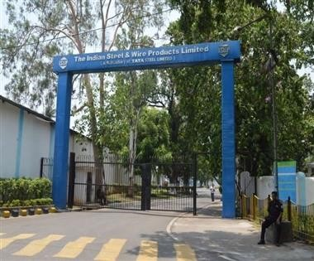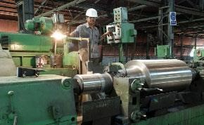

JEMCO has the best melting furnaces to manufacture different grades and customized products like rolls and engineering castings. JEMCO has two Arc Furnaces of 10 MT and 5 MT, which are used to manufacture high-strength alloy iron, high-quality SG iron, and alloy steel rolls. The 8 MT coreless induction furnace is used for small and medium-size Cast Iron, Steel, and SG Rolls. These furnaces are also used for the manufacturing of various grades of engineering casting. The Dual Track Induction Furnace of 0.75 MT and 1.5 MT is used for high alloyed low weight castings and rolls. These furnaces also provide highly alloyed shell metal for static cast rolls. The wide variety of Furnaces offers complete flexibility in producing rolls and engineering casting of different sizes and weights. Melting is carried out using segregated scrap, pig iron, and ferroalloys to achieve the desired composition.

**2. Introduction**

This Project has been made to study the Rolling Processes. It includes concise information about the Rolling processes and Yield loss points some methods that can be applied to reduce the scrap.

For the Rod Mill section nearly 3% to 4% of the material is lost while processing. This loss even if looks smaller can add up to a huge number of lost material and capital.

# 3. Pre-Rolling Processes:

1. **Billet Yard:**

Raw material is stored here with help of cranes and placed on Billet bench.

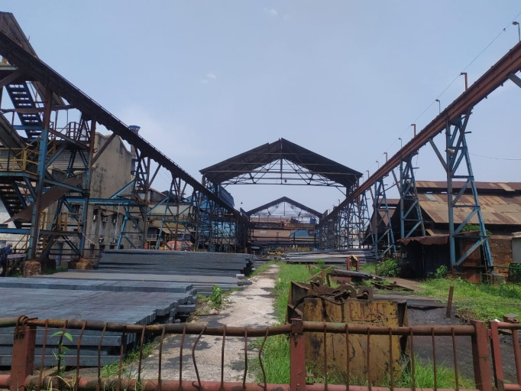

1. **Furnace:**

With the help of Cold Pusher billets are placed into furnace at temperature of 1250 to 1300 degree Celsius.

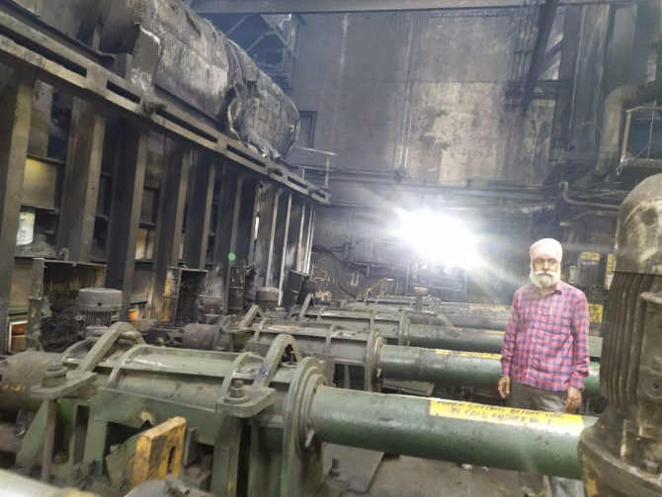

1. **Hot Pusher :**

Pushes one Billet by each towards Stand no.1.

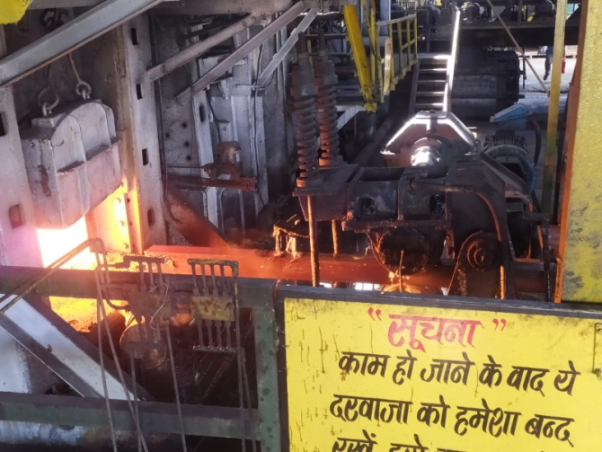

# 4. Rolling Processes

* The Definition : Rolling is a metal forming process in which metal stock is passed through one or more pairs of rolls to reduce the thickness, to make the thickness uniform, and/or to impact a desired mechanical property. If the temperature of the metal is above its [recrystallization](https://en.wikipedia.org/wiki/Recrystallization_(metallurgy)) temperature, then the process is known as **hot rolling**. If the temperature of the metal is below its recrystallization temperature, the process is known as **cold rolling**.

# Types of Rolling Processes:

* Thread/Gear Rolling
* Shape Rolling
* Ring Rolling
* Tube Piercing
* Transverse Rolling/Roll Forging
* Skew Rolling
* Roll Bending
* Flat Rolling
* Controlled Rolling

# Types of Rolling Mills:

# 

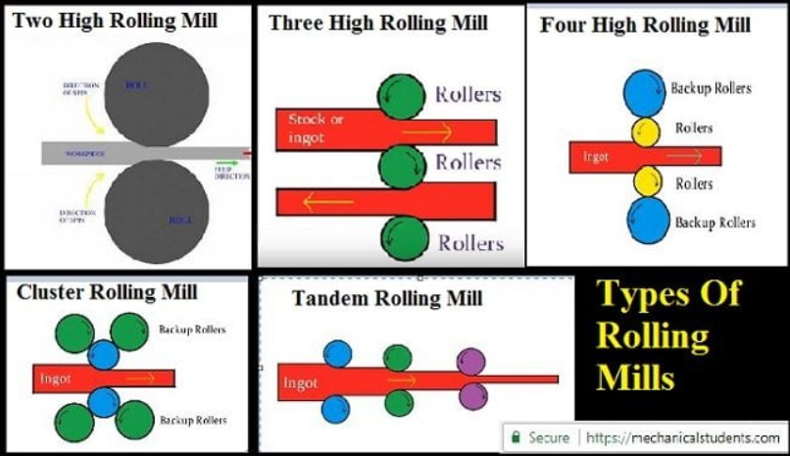

Rolling mill type in the Rod Mill Department is Tandem Rolling Mill.

# Rolling Processes in Rod Mill

# Functions

* **Roughing :**

Roughing area mainly focuses on Reduction of the cross section area by a huge margin in order to mold the square cross section into circular it uses RTD guides.

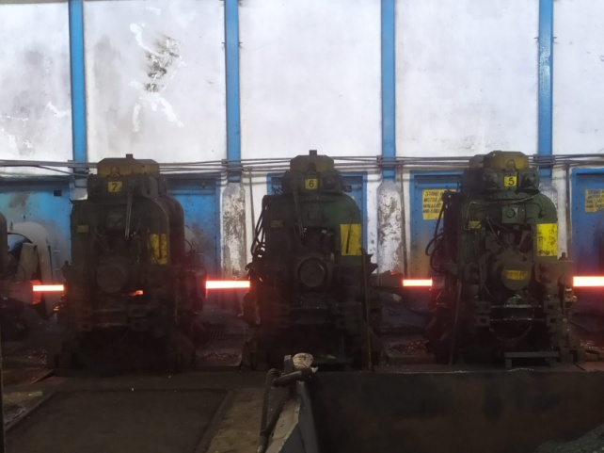

* **Intermediate :**

Intermediate area has lesser temperature of the processing material therefore in order to avoid the cooler ends in shear 9 it goes through head and tail cut and then a gradual decrease of diameter.

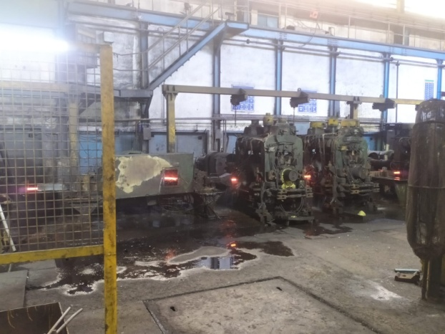

* **NTM (Non Twisted Mill):**

At this stage main focus is not on reducing the cross sectional area but on finishing of the product. Spiral gauging in Case of TMT bars.

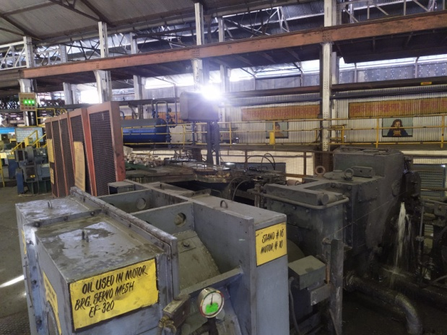

# 

**Stand Wise Study of RollIng Processes**

Important Parameters of Rolling Process

* Stand No
* Number of Passes
* Pass Profile
* Stock Size
* Entry Guide
* Exit Guide
* Types of Guides

RTD (Roller Twister Delivery Guide)

RE (Roller Entry Guide)

RF (Round Friction Guide)

Friction Guide

**Roughing And Intermediate Stands**

|  |  |  |  |  |
| --- | --- | --- | --- | --- |
| **Stand No** | **Number of Passes and Pass Profile** | **Stock Size** | **Entry Guide** | **Exit Guide** |
| 1 | 4 Box | 90.6×146 | Friction | Friction |
| 2 | 4 Box | 62.5×153.5 | Friction | RTD |
| 3 | 4 Box | 85×88 | Friction | Friction |
| 4 | 4 Oval | 58×101 | Friction | RTD |
| 5 | 4 Round | 69×70 | RE | RF |
| 6 | 4 Oval | 38×84 | Friction | RTD |
| 7 | 4 Round | 55×49 | RE | RF |
| 8 | 6 Oval | 31×69 | Friction | RTD |
| 9 | 6 Round | 41×41 | RE | RF |
| 10 | 8 Oval | 20.5×51 | Friction | RTD |
| 11 | 8 Round | 29.5×30 | RE | RF |
| 12 | 12 Oval | 16.5×38 | Friction | RTD |
| 13 | 12 Round | 23×23.5 | RE | RF |
| 14 | 16 Oval | 15×28 | Friction | RTD |
| 15 | 16 Round | 18.9×19.7 | RE | RF |

**Non Twisted Mill (NTM) Stands**

|  |  |  |  |  |
| --- | --- | --- | --- | --- |
| **Stand No** | **Number of Passes and Pass Profile** | **Stock Size** | **Entry Guide** | **Exit Guide** |
| 16 | 2 Oval | 10.7x20 | Fixed Guide | Nozzle |
| 17 | 2 Round | 13.7 | 820 A/1 | Nozzle |
| 18 | 2 Oval | 8.7x16 | Fixed Guide | Nozzle |
| 19 | 2 Round | 11.1 | 820 A | Nozzle |
| 20 | 2 Oval | 6.7x14 | Fixed Guide | Nozzle |
| 21 | 2 Round | 8.9 | 820 A | Nozzle |
| 22 | 2 Oval | 5.5x11 | Fixed Guide | Nozzle |
| 23 | 2 Round | 7.2 | 820 A | Nozzle |
| 24 | 2 Oval | 4.4x8.2 | Fixed Guide | Nozzle |
| 25 | 4 Round | 5x57 | 820 A | Nozzle |

# 5. Yield Improvement and Scrap Reduction.

**Methodology**

* Identifying Yield Losses in Total

-Sources of Yield Loss

-Reasons of yield Loss

-Material and capital lost due to it

-Suggestions for Yield Improvement

* Identifying Sources of Scrap

-To know the reasons for Scrap production

-To find and suggest methods for Scrap reduction

**Yield Losses in Rod Mill and Its Sources :**

|  |  |
| --- | --- |
| **Yield Loss** | **Source** |
| 1) Scales | Furnace, Stands |
| 2) Cobble | Roughing, Intermediate, NTM , Roller table |
| 3) Head and Tail end Crop | Shear 9 , Shear 15 |
| 4) Uncooled Losses (TMT) | Water box |
| 5) Billet Bending | Billet Yard |
| 6) Rust Losses in Storage | Storage Yards |
| 7) Wrong Product | NTM , Roller table, Decoiling unit |
| 8) Finished Goods Losses | Decoiling Mill |

1. **Reasons for the Yield Losses**
2. **Scales** :

Oxidation of the hot billets due air contact of metal at high temperature.

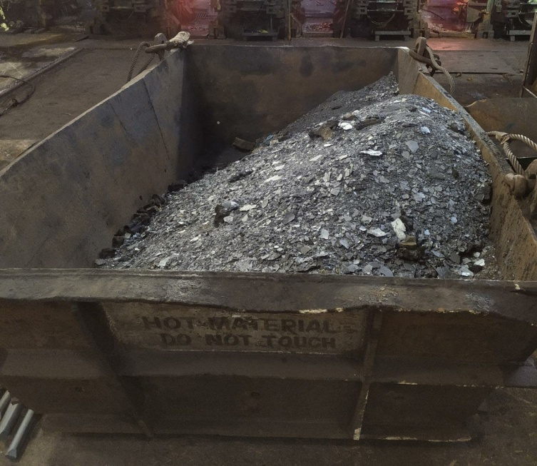

1. **Cobble** :

*Roughing and Intermediate :

- Breakdown due to not proper selfing

- Guides not aligned properly (manual mistake)

- Roll Bearings , Roll selfing , Roll Gauging ( Not proper equipment)

- Equipment damage due to Cold metal

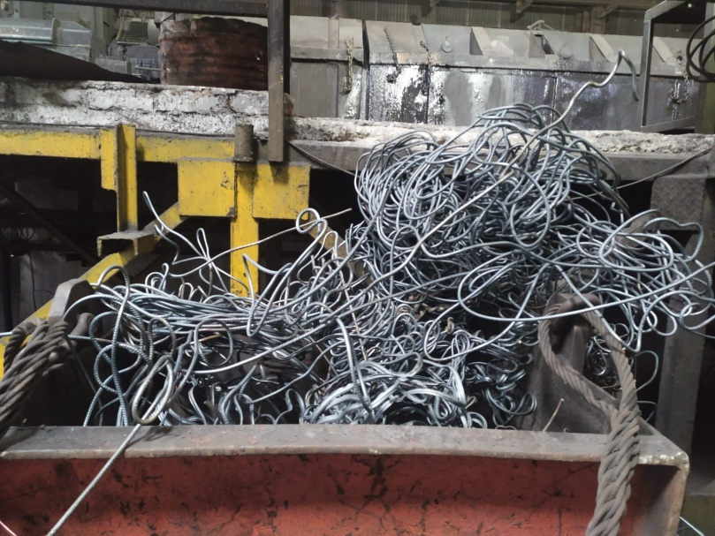

**\*Roller Table (Jamming) :**

- Roller Table Hooking

- Motor Tripping 0 to 17 no motor

- Bad Quality of Metal

- Laying of Coil in Oval Shape

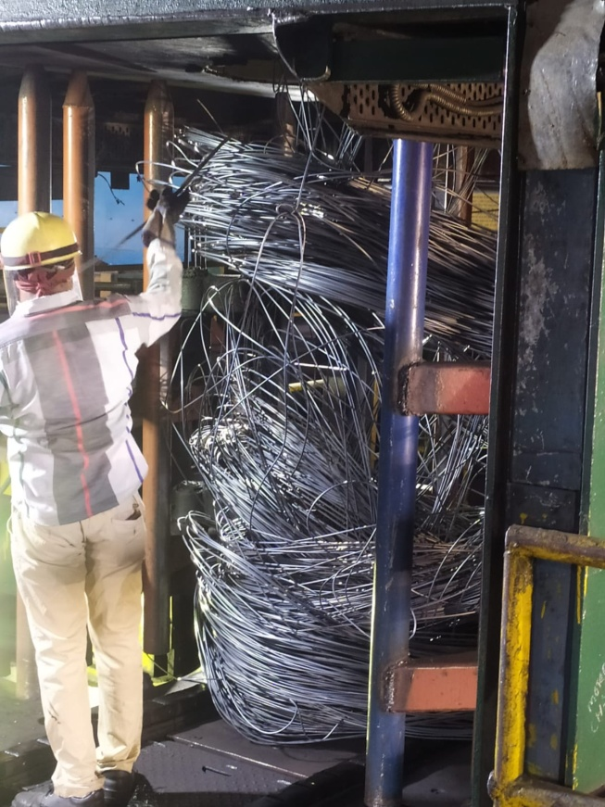

1. **Shear 9 , Shear 15 :**

To Avoid the cooled and non uniform ends which can bring complications for

further rolling.

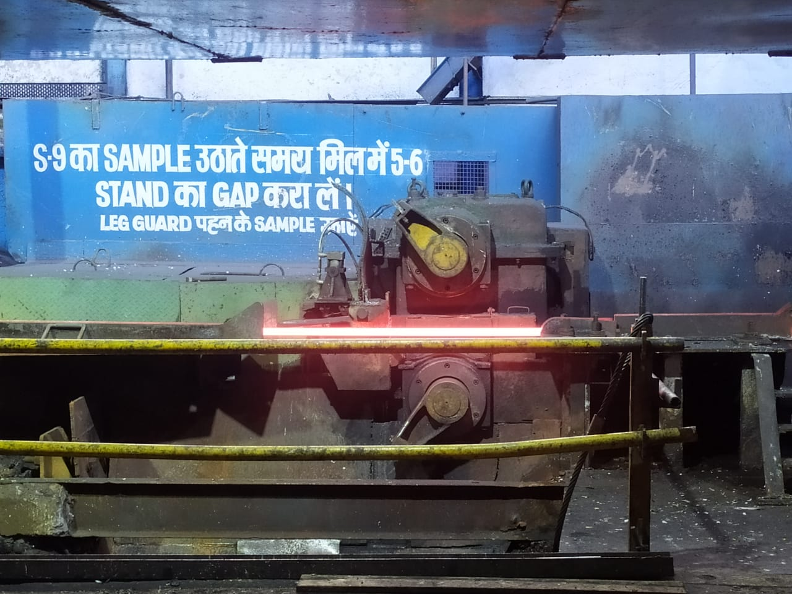

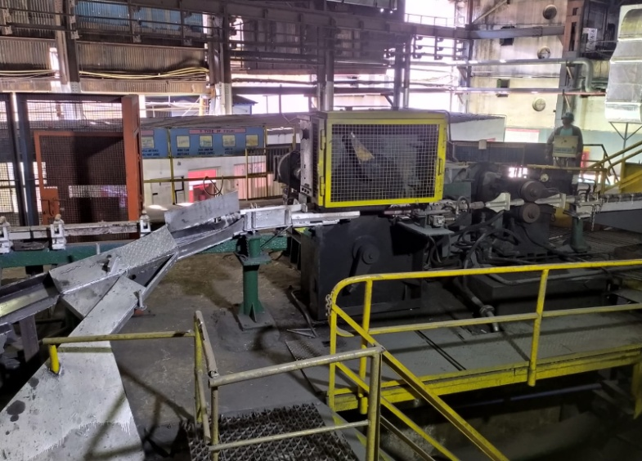

**4. Uncooled Losses in TMT:**

There is time lag inside the waterbox between water flow and material passing therefore a length of material remains uncooled and hence not having the quality required for TMT rods.

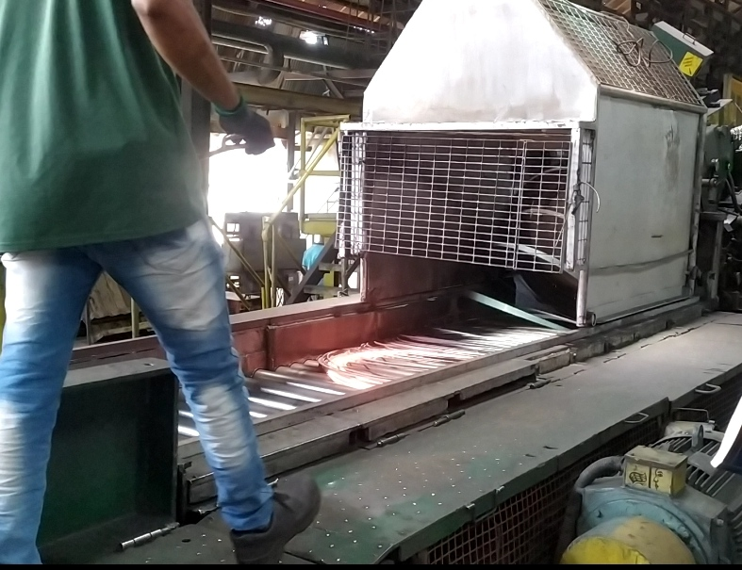

**5.Billet Bending:**

While shifting Billets from loaded trucks to Ground or to the Billet Bench due to power tripping and failure in the electromagnet. Billets are straightened by use of hydraulic press , which delays the process and eventually the process.

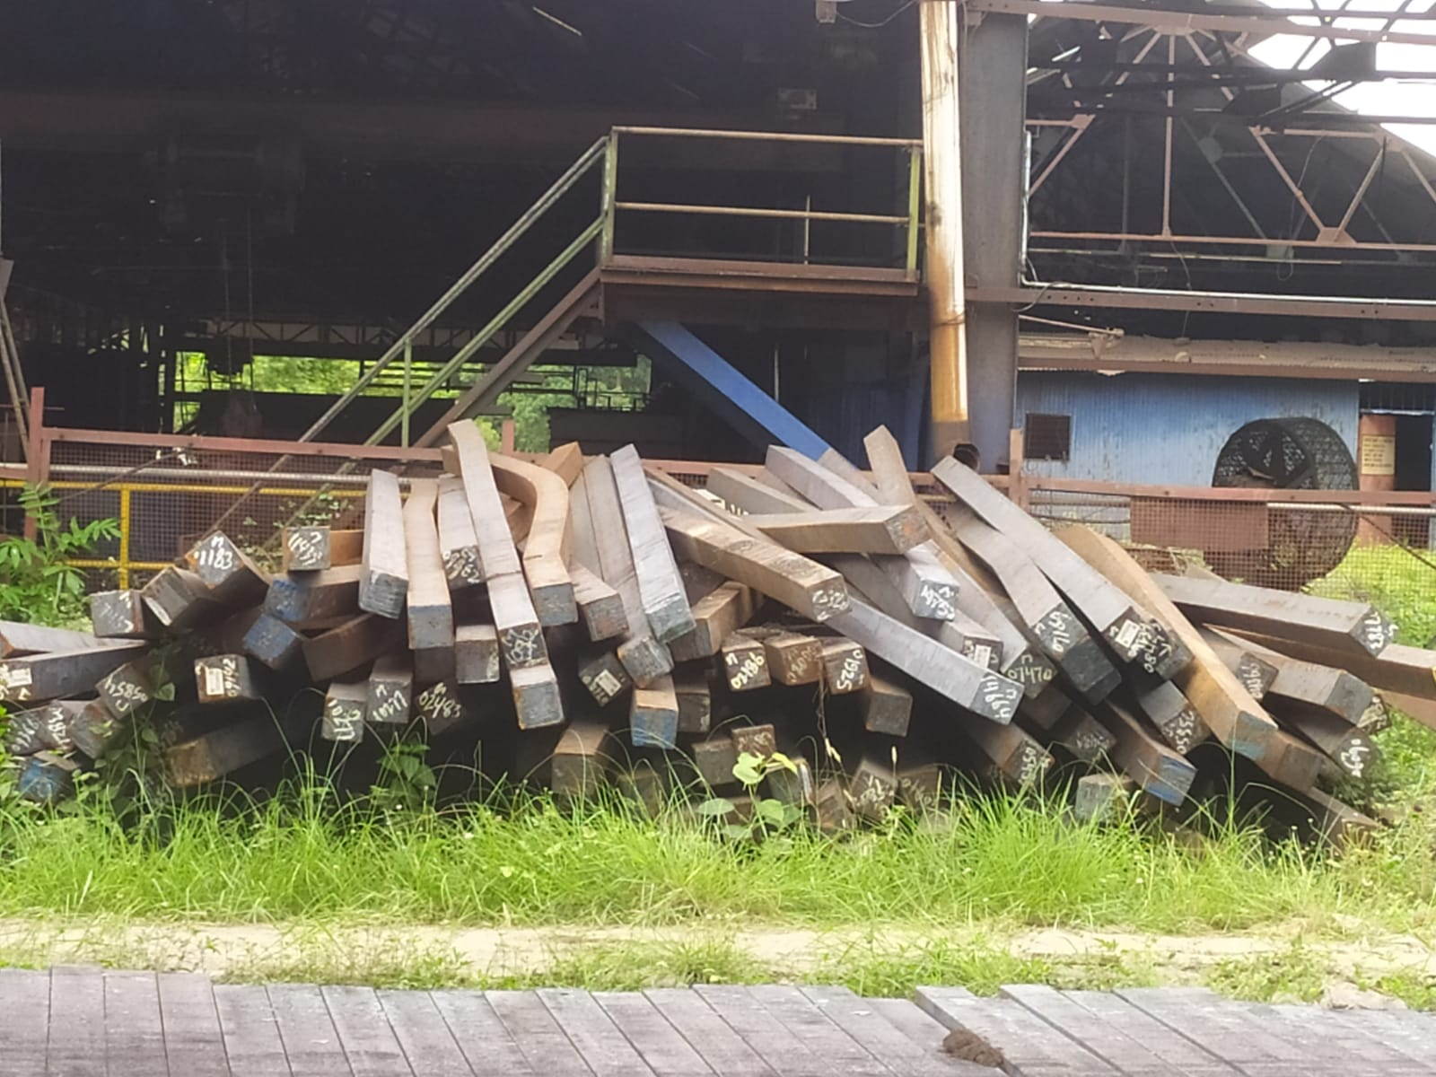

**6.Rust Losses in Storage:**

When Coils are shifted by the Cranes and kept for storage. Due to not proper protection from atmosphere and storage facilities many coils are scrapped due to rust.

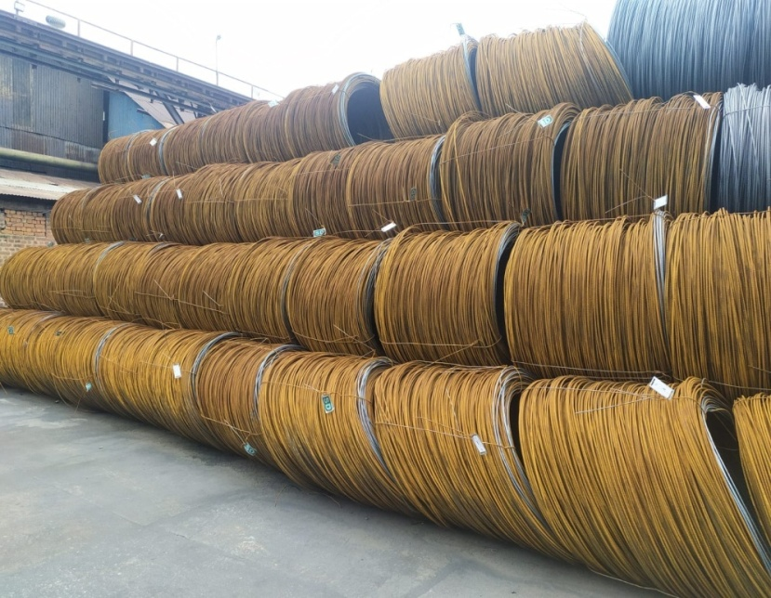

**7.Wrong Product:**

If the produced product doesn’t match the quality demanded then it is due to raw material problems or due to defect in processing

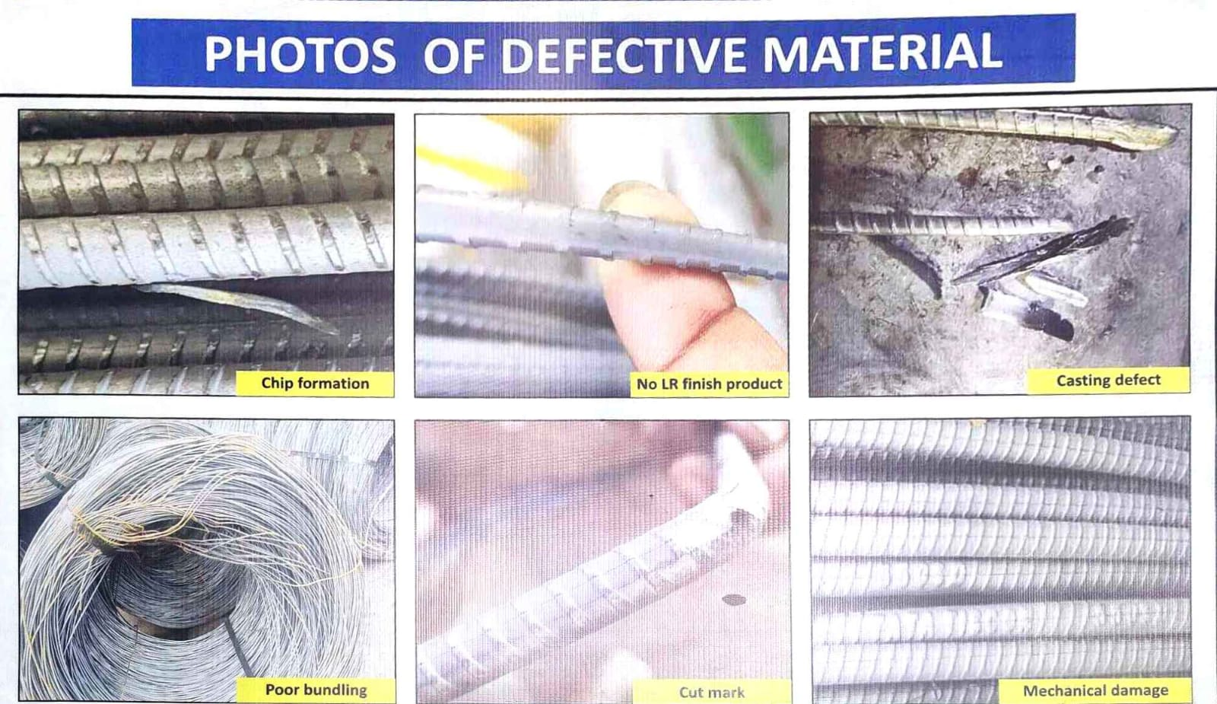

**8. Finished Goods Losses:**

During Decoiling of the Coils there is scrap left behind in some quantities as all TMT bars are cut in length of 12 m and also some length of coil is lost to testing.

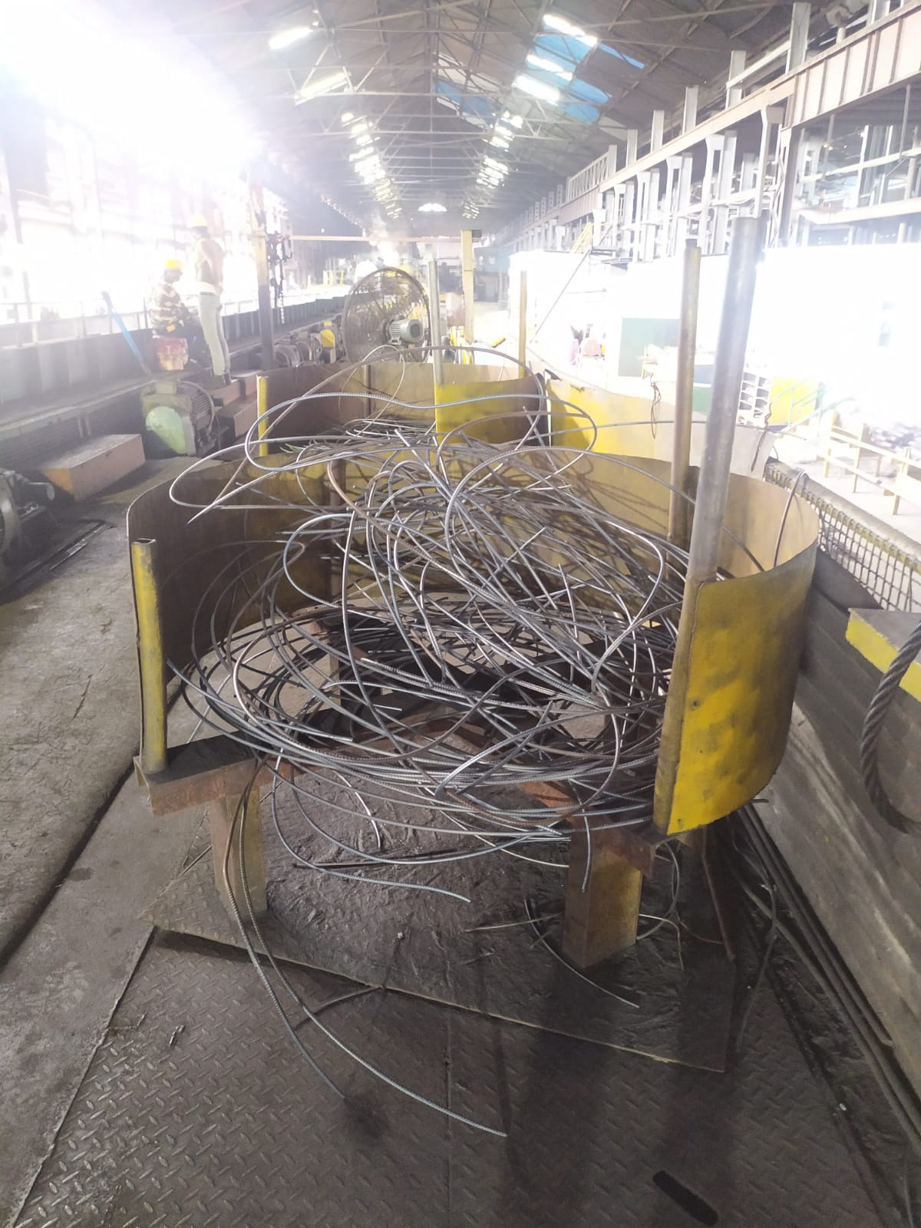

1. **Yield Loss Calculation per Billet**

* Weight of one Billet = 1.170 tonnes
* Weight of the Finished Products per Billet/Per Coil

8 mm Coil Weight per metre = 380-390 gm/m

6 mm Coil Weight per metre = 210-220 gm/m

5.5 mm Coil Weight = 1.140 tonnes

**Losses For 8mm TMT bars**

* For 1 Section of 8mm
* No of Billets Rolled = 14001
* No of Cobble = 16
* Production in Tonnes : 15540 tonnes
* Weight of Scrap at Shear 9 per billet = 8 kg
* Weight of Scrap at Shear 15 per billet = 2.5 kg
* Weight of Scales produced in Processing(lost material) = 12 kg
* Weight of Uncooled Rings at Decoiling Mill = 15 front and 1 back ring = 16 rings

1 ring = 3 m : 16 x 3 x 385gm = 18.48 kg

* Weight of Scales produced in Decoiling Mill = 0.11 kg
* Weight of FG per billet = 1.122 tonnes
* Yield loss Percentage Calculation = (1170- 1109.9) x 100/1170 = 4.096%

Total Yield = 100 – 4.096 = 95.904%

**Losses for 6mm TMT bars**

* For 1 Section of 6mm
* No of Billets Rolled = 1741
* No of Cobble =9
* Production in Tonnes : 1933 tonnes
* Weight of Scrap at Shear 9 per billet = 8 kg
* Weight of Scrap at Shear 15 per billet = 2.5 kg
* Weight of Scales produced in Processing(lost material) = 12 kg
* Weight of Uncooled Rings at Decoiling Mill = 16 front and 2 back ring = 18 rings

1 ring = 3 m : 18 x 3 x 215 gm = 11.61 kg

* Weight of Scales produced in Decoiling Mill = 0.11 kg
* Weight of FG per billet = 1.1103 tonnes
* Yield loss Percentage Calculation = (1170 – 1110.3) x 100/1170 = 5.104 %

Total Yield = 100 – 5.104 = 94.896 %

**Losses for 5.5 mm Wires**

* For 1 Section of 5.5mm
* No of Billets Rolled = 4737
* No of Cobble =13
* Production in Tonnes : 5257 tonnes
* Weight of Scrap at Shear 9 per billet = 8 kg
* Weight of Scrap at Shear 15 per billet = 2.5 kg
* Weight of Scrap Produced at Roller table
* Weight of Scales produced in Processing(lost material)
* Weight of FG per billet = 1.14 tonnes
* Yield loss Percentage Calculation =(1170 – 1140) x 100/1170 = 2.564%

Total Yield = 100 – 2.564 = 97.435%

**Production Rate**

For May 2022

* Total production 22730 tonnes
* Total Coils = 20480 (cobble not included)

1. **Suggested Remedies for the Yield Losses and Scrap Reduction**

* Scales Reduction:
* Cobble:
* Shear 9 , 15
* Water Box Losses reduction
* Billet Bending
* Rust losses
* Wrong Product
* Finished Good Losses
* **Scales Reduction**

**Protective Coatings Increase Material Yield and Reduce Costs**

**Burning Loss Due to Oxidation**

O2 + 2 Fe ↔ 2 FeO

O2 + 4 FeO ↔ 2 Fe2O3

CO2 + Fe ↔ CO + FeO

 CO2 + 3 FeO ↔ Fe3O4 + CO

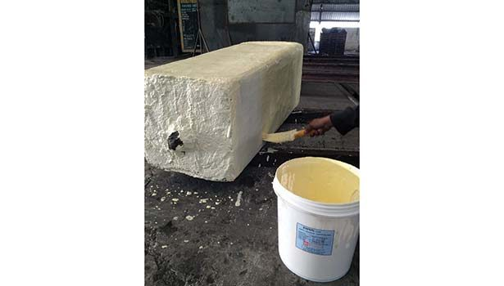

**Characteristics of Protective Coating and its Use**

* An anti-scale coating is applied on billets/ingots to be heated before charging them into the furnace.
* Acts as a barrier between the metal and oxygen. Before heating, care is taken to apply a uniform, impervious coating on the billet to be heated.
* Heat transfer from the heating medium to the metal unaffected by the coating, which also reduces decarburization on billets during hot-rolling operations.
* No reaction with the steel surface; no release of toxic fumes during use, hot forging or storage; and it is otherwise nonhazardous.

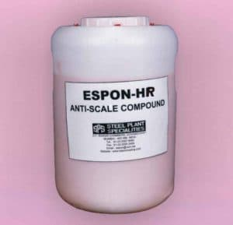

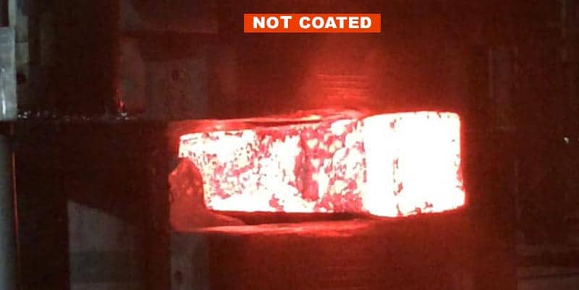

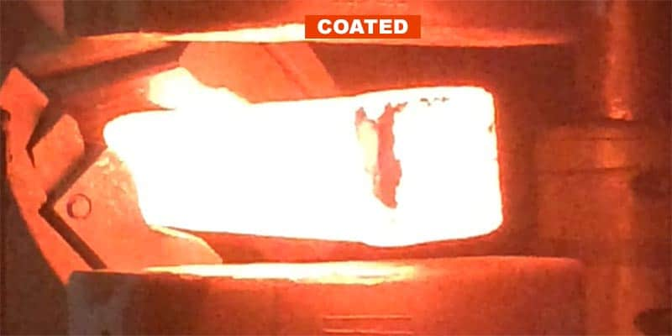

**Protective Coating Increases Yield**

•   Total reduction in scale = 0.95 mm

•   Percentage reduction in material loss due to mill scale by using anti-scale coating = 56.98%

•   Approximately a 70% reduction in mill scale is achieved by anti-scale coating in hot rolling of stainless steel.

 •   Scale loss of 2.14 kg was observed on billets without coating.

•   Scale loss of 1.140 kg was observed on billets with a double layer of protective anti-scale coating.

•   Percentage reduction in mill scale loss due to use of protective anti-scale coating = 47.00%

* **Cobble**
* **Design of Modified Side Guide System:Add description**

The side guide measurement system in finishing mill was found to be not accurate due to backlash between the motor and gear box. A modified system was designed and installed in the mill . The gap between two guides is measured by an incremental encoder. The output signal of the encoder is connected to a counter module of a Programmable Logic Controller (PLC). The output of counter module is processed by the central processing unit (CPU) of the PLC where the signal is converted to analog values.

* **Signal Analysis of Finishing Mill Parameters**

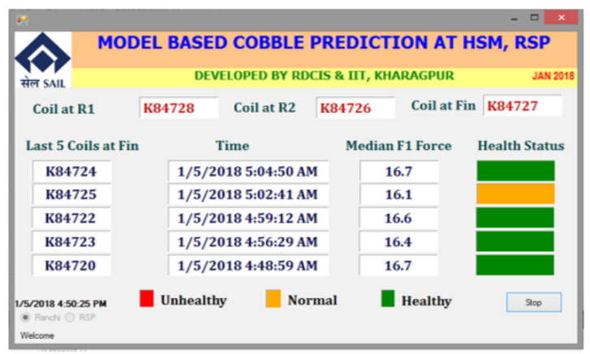

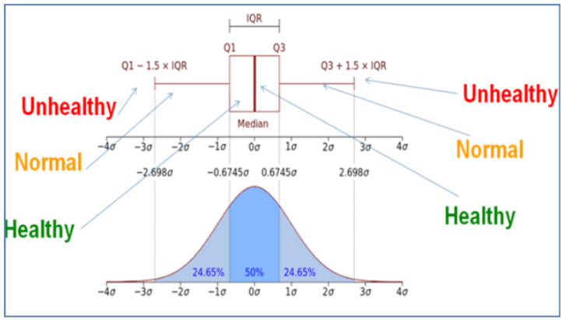

* **Study of Process Parameters**

The thermo-vision photograph taken in April 2017 after descaler is shown in Figure-5.

Temperature variation across slab width was about 60 0C which was the main factor

for creating strip waviness in the mill.

Based on the study report, the shop had taken actions in reducing temperature

variations across slab width by improving reheating furnace, descaler and roll cooling

systems. This has resulted in decrease of temperature variation across strip width from

25-30 oC before to 5-10 oC as shown in Figure-6

The thermo-vision photograph taken in April 2017 after descaler is shown in Figure-5.

Temperature variation across slab width was about 60 0C which was the main factor

for creating strip waviness in the mill.

Based on the study report, the shop had taken actions in reducing temperature

variations across slab width by improving reheating furnace, descaler and roll cooling

systems. This has resulted in decrease of temperature variation across strip width from

25-30 oC before to 5-10 oC as shown in Figure-6

The thermo-vision photograph taken in April 2017 after descaler is shown in Figure-5.

Temperature variation across slab width was about 60 0C which was the main factor

for creating strip waviness in the mill.

Based on the study report, the shop had taken actions in reducing temperature

variations across slab width by improving reheating furnace, descaler and roll cooling

systems. This has resulted in decrease of temperature variation across strip width from

25-30 oC before to 5-10 oC as shown in Figure-6

The thermo-vision photograph taken in April 2017 after descaler is shown in Figure-5.

Temperature variation across slab width was about 60 0C which was the main factor

for creating strip waviness in the mill.

Based on the study report, the shop had taken actions in reducing temperature

variations across slab width by improving reheating furnace, descaler and roll cooling

systems. This has resulted in decrease of temperature variation across strip width from

25-30 oC before to 5-10 oC as shown in Figure-6

The thermo-vision photograph taken in April 2017 after descaler is shown in Figure-5.

Temperature variation across slab width was about 60 0C which was the main factor

for creating strip waviness in the mill.

Based on the study report, the shop had taken actions in reducing temperature

variations across slab width by improving reheating furnace, descaler and roll cooling

systems. This has resulted in decrease of temperature variation across strip width from

25-30 oC before to 5-10 oC as shown in Figure-6

The thermo-vision photograph taken in April 2017 after descaler is shown in Figure-5.

Temperature variation across slab width was about 60 0C which was the main factor

for creating strip waviness in the mill.

Based on the study report, the shop had taken actions in reducing temperature

variations across slab width by improving reheating furnace, descaler and roll cooling

systems. This has resulted in decrease of temperature variation across strip width from

25-30 oC before to 5-10 oC as shown in Figure-

The thermo-vision photograph taken in April 2017 after descaler is shown in Figure-5.

Temperature variation across slab width was about 60 0C which was the main factor

for creating strip waviness in the mill.

Based on the study report, the shop had taken actions in reducing temperature

variations across slab width by improving reheating furnace, descaler and roll cooling

systems. This has resulted in decrease of temperature variation across strip width from

25-30 oC before to 5-10 oC as shown in Figure-6

The thermo-vision photograph taken in April 2017 after descaler is shown in Figure-5.

Temperature variation across slab width was about 60 0C which was the main factor

for creating strip waviness in the mill.

Based on the study report, the shop had taken actions in reducing temperature

variations across slab width by improving reheating furnace, descaler and roll cooling

systems. This has resulted in decrease of temperature variation across strip width from

25-30 oC before to 5-10 oC as shown in Figure-6

The thermo-vision photograph taken in April 2017 after descaler is shown in Figure-5.

Temperature variation across slab width was about 60 0C which was the main factor

for creating strip waviness in the mill.

Based on the study report, the shop had taken actions in reducing temperature

variations across slab width by improving reheating furnace, descaler and roll cooling

systems. This has resulted in decrease of temperature variation across strip width from

25-30 oC before to 5-10 oC as shown in Figure-6.

The thermo-vision photograph taken in April 2017 after descaler is shown in Figure-5.

Temperature variation across slab width was about 60 0C which was the main factor

for creating strip waviness in the mill.

Based on the study report, the shop had taken actions in reducing temperature

variations across slab width by improving reheating furnace, descaler and roll cooling

systems. This has resulted in decrease of temperature variation across strip width from

25-30 oC before to 5-10 oC as shown in Figure-6.

The thermo-vision photograph after descaler is shown . Temperature variation across slab width was about 60 0C which was the main factor for creating strip waviness in the mill.

Based on the study report, the shop had taken actions in reducing temperature variations across slab width by improving reheating furnace, descaler and roll cooling systems. This has resulted in decrease of temperature variation across strip width from 25-30 oC before to 5-10 oC as shown.

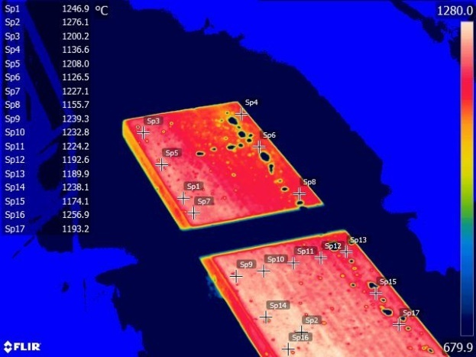 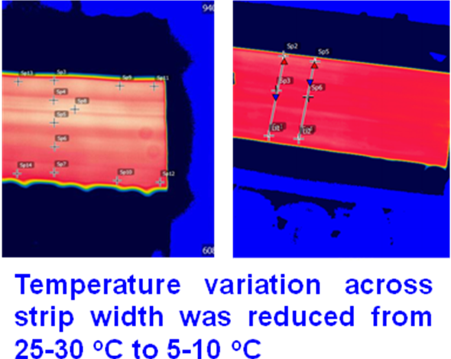

Thermovision pictures of slab after descaling Thermovision pictures after last finishing stand

* **Shear 9 , 15**
* Only fractured part of Head and Tail must be removed by the Operator
* Currently Shear15 cuts length of 1.5 m instead of 0.75 m
* Regular maintenance of the Operating systems and sensors.
* Implementation of Machine learning programmes for accurate results

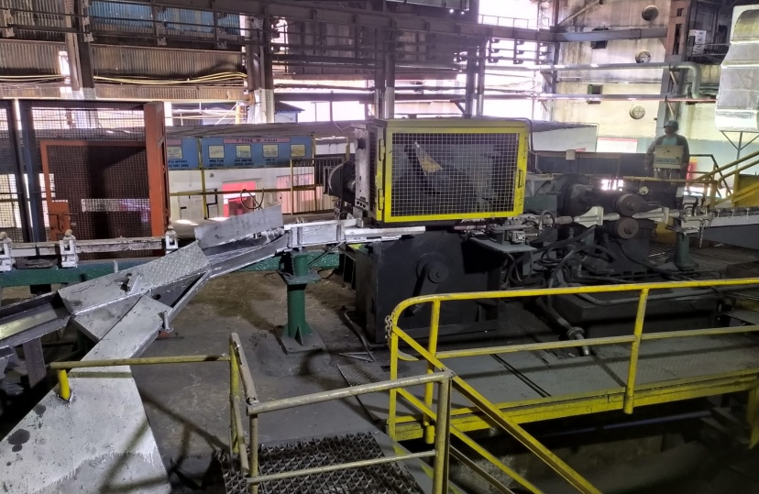



* **Water Box Losses Reduction**

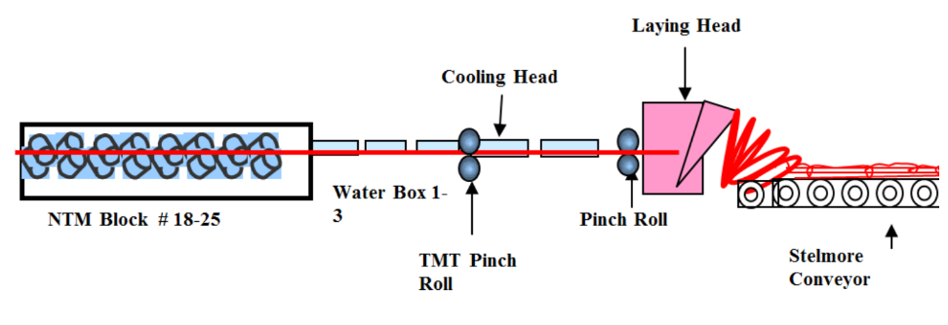

* Separate water supply systems for each water boxes, as shown in line diagram below

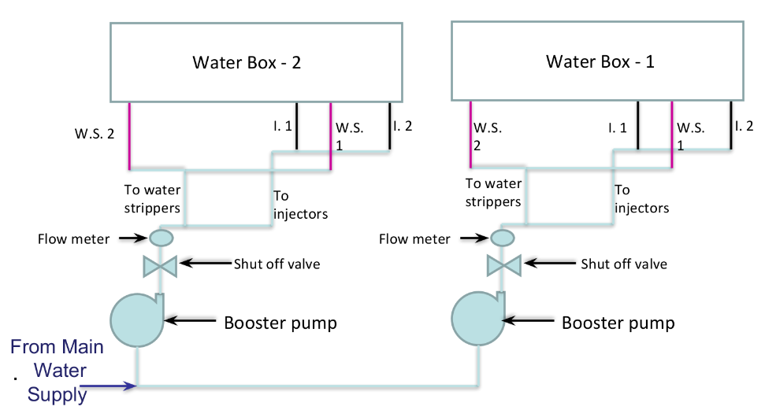

**Replacement of Coiling System with Straight Bar System**

* It will avoid the extra efforts for the Decoiling Mill
* It will minimize the losses due to uncooled rings as it will become easy for segregation of uncooled material.
* Once segregated, initial uncooled part can be cooled manually.

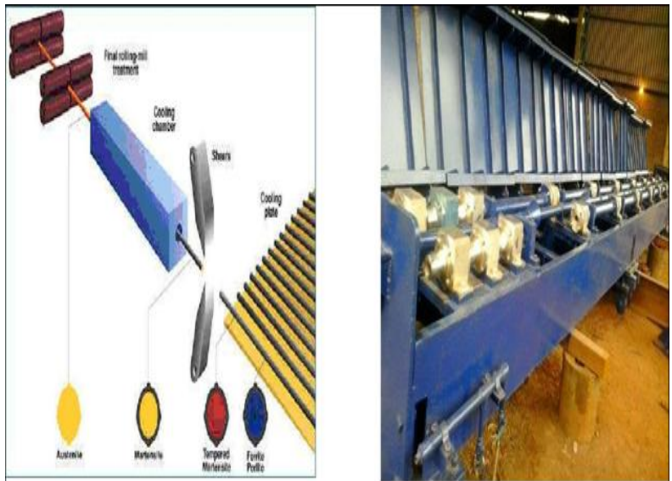

* **Billet Bending**

Avoiding Power Trip in the Billet yard area

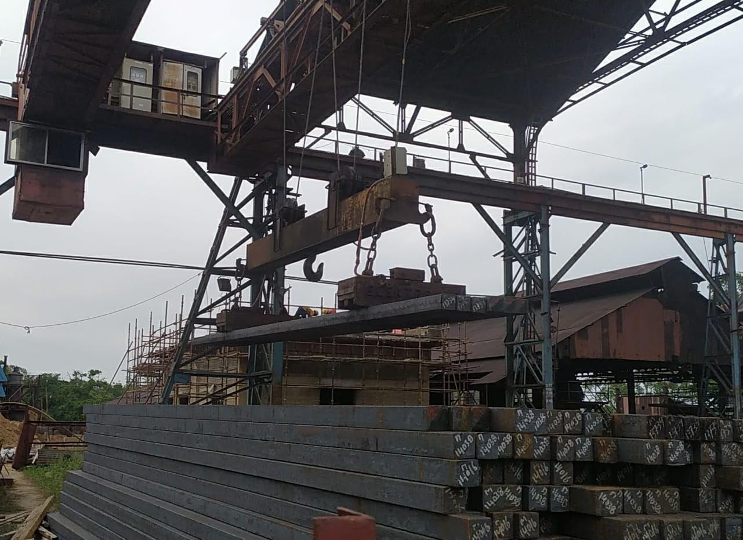

* **Rust Losses**
* Development of the Warehouses
* Develop ways to for Rust resistance of FG

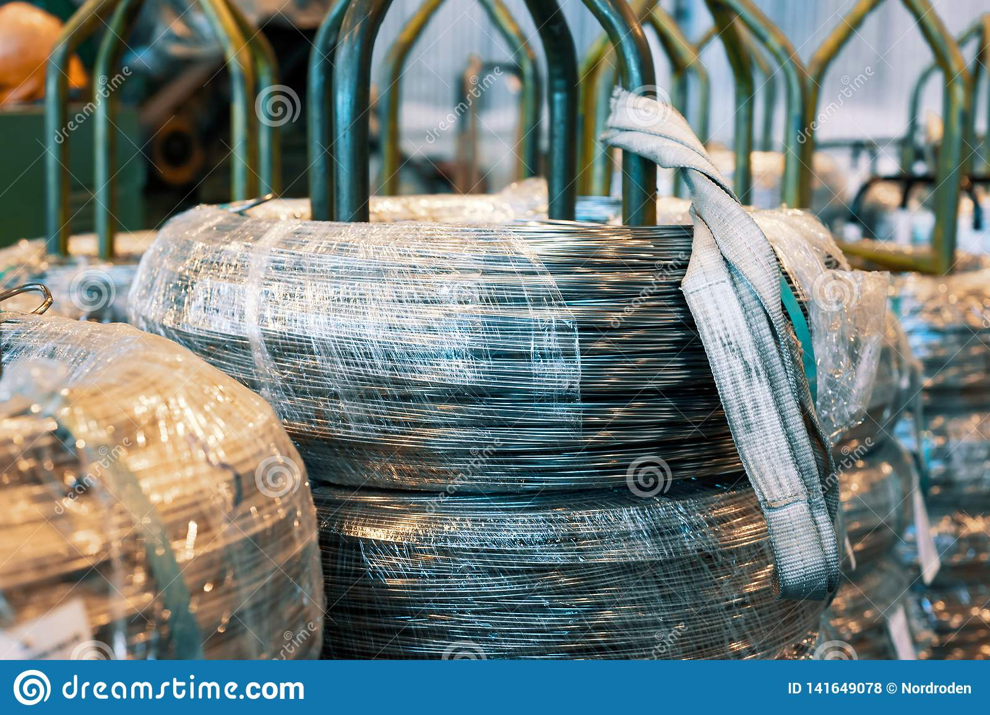

* **Finished Good Losses**
* Shear 9 and 15 cutting length

In order to Avoid FG losses for TMT bars length of Coil can be adjusted to obtain just at multiple of 12 metres

Billet size = 130 x 130 x 9 m

Stock size at S9 = 41 x 41 weight removed=8 kg(61.86cm)

Stock size at S15 = 18.9 x 19.7 weight removed=2.5 kg(87.3cm)

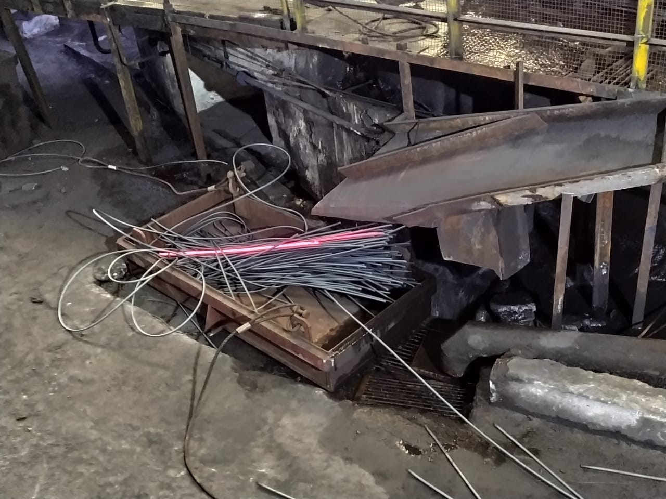

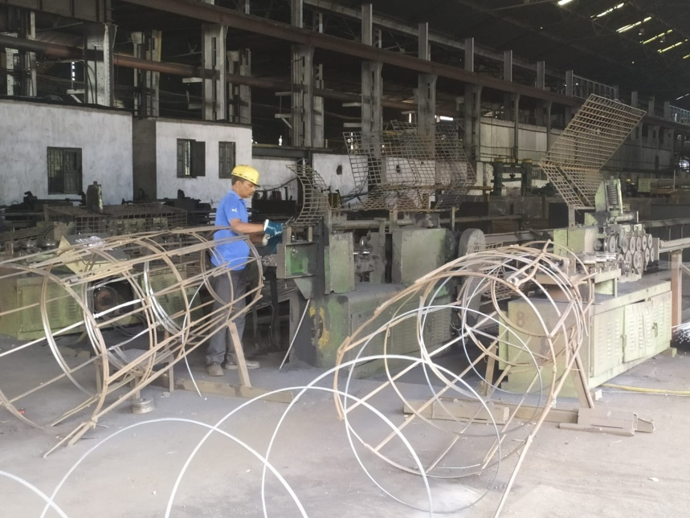

1. **Results**

* Yield obtained per Billet

22730 x 100/ (20480 x 1.170)= 94.86%

* Yield loss per Billet = 100- 94.86= 5.14%
* Capital loss behind a Billet and Finished Good

5.14/100 x 23,229.35 Rs = 1193.96 Rs

* Monthly Losses Due to Cobble

= 38 x 23,229.35 = 8,82,715.3 Rs

# CONCLUSION

* The production of the Company is pretty much impressive and demanded by market for its quality and brand but with the new tools and technologies at hand it is necessary for such firm to introduce new automation methods in the operating sector rather than dependence on the manual operating. Eg, machine learning
* For the machining part flexibility of the process needs to be much more than its present condition in order for the company to be sustainable according to the future.
* At present there is much less scope for the testing part of any process at the company for any new changes. This issue needs to be resolved by developing some simulation methods Eg, Ansys . Or else with the help of some model based testing.
* Data collection at various departments regarding Raw material , Production , Failures should be widely increased for the purpose of proper analysis.
* Only three types of products are manufactured in Rod mill department when it has potential to increase a lot making process flexible and decreasing the time for section change.

# Reference

* *https://iswp.co.in/*
* *“Reduction of Mill Scale generated by Steel processing”*

*https://www.researchgate.net/publication/288874180_Reduction_of_mill_scale_generated_by_steel_processing*

* *“Protective Coatings increase material Yield and Reduce Costs”*

*https://www.forgemag.com/articles/84248-protective-coatings-increase-material-yield-and-reduce-costs*

* *“Anti Scale Protective Coatings”*

*https://steelplantspecialities.com/anti-scale-protective-coatings/#*

* *“Scale development on steel during hot strip rolling”*

*file:///C:/Users/kunal/Downloads/gruppofratturaojs,+Journal+manager,+1227-4752-1-CE%20(1).pdf*

* *“Reduction of Cobble Generation in Hot Strip Mill”*

*https://www.researchgate.net/publication/329644069_Reduction_of_Cobble_Generation_in_Hot_Strip_Mill*

* “Selection of Effective Control factors for TMT Bars using Taguchi”

*https://www.ijeat.org/wp-content/uploads/papers/v8i6S3/F12600986S319.pdf*

* *“Industrial Warehouse of cold rolled wire. The wire coils are stacked off the stack” https://www.dreamstime.com/industrial-warehouse-cold-rolled-wire-coils-stacked-off-stack-image141649078*